Sex Predicting Sleep Efficiency: Simple Regression vs. T-test

*The data set includes the following variables:*

*•* ***sex:*** *1=male, 2=female*

*•* ***age:*** *Participant’s age in years*

*•* ***anxiety:*** *Participant’s level of general anxiety measured at the start of the study via a multi-item scale. The scale (average of all items) ranges from 1 to 7, where a higher score indicates a higher level of anxiety.*

*•* ***prior:*** *An indicator of whether or not the participant had previously participated in some type of sleep intervention, 1 = yes, 0 = no.*

*•* ***hygiene:*** *Participant’s sleep hygiene at week 6. It ranges from 0 to 10, and higher means better sleep practices.*

*•* ***support:*** *Participant’s perception that their partner is supportive of their struggles with sleep and their efforts to improve sleep. It is a multi-item scale that ranges from 1 to 5, where higher indicates more support.*

*•* ***sleep:*** *Participant’s average sleep efficiency during the month following the intervention, calculated as time spent in bed asleep (minus all the awakenings), divided by the total time spent in bed. It is expressed as a percentage.*

*•* ***lifesat:*** *Participant’s sense of life satisfaction measured 30 days after the completion of the intervention. It is a multi-item scale that ranges from 1 to 7, where a higher score indicates more satisfaction.*

*•* ***cond:*** *Treatment condition, 1 = self-help, 2 = group-based intervention, 3 = group-based plus partner participation.*

1. Read in the data "slpdata.csv"
2. Install the package “afex”
3. Run this code to format the data:

slp <- mutate(slp,

female = ifelse(sex == 1, 0, 1),

female.f = factor(female, levels = c(0,1), labels = c("male", "female")),

cond2 = ifelse(cond == 2, 1, 0),

cond3 = ifelse(cond == 3, 1, 0),

cond.f = factor(cond, levels = c(1,2,3), labels = c("self help", "group-based", "group + partner")),

anxiety.m = anxiety - mean(anxiety))

1. Run this code to get the sleep efficiency means for males and females. We want to determine if these means are significantly different



1. Run this code to conduct an ANOVA
   1. An ANOVA with a single predictor that has two levels is the same as a t-test



* 1. Results:

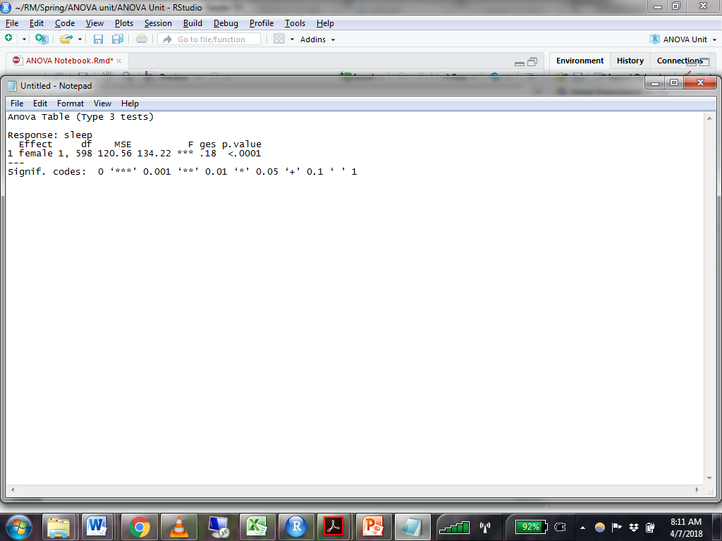

* + 1. The F statistic provided in the output tells us if our predictor explains any variance in the outcome, but doesn’t provide comparative information about the groups.
       1. In this case we only have one predictor with two levels, so we know that the significant F statistic must indicate a difference between males and females.
    2. “ges” is generalized eta squared, the effect size for our predictor. It indicates the proportion of variance in the outcome that is explained by the predictor.

1. To get more information, we need to conduct some follow-up analyses. Run this code to get the estimated marginal means and confidence intervals for each level of our predictor

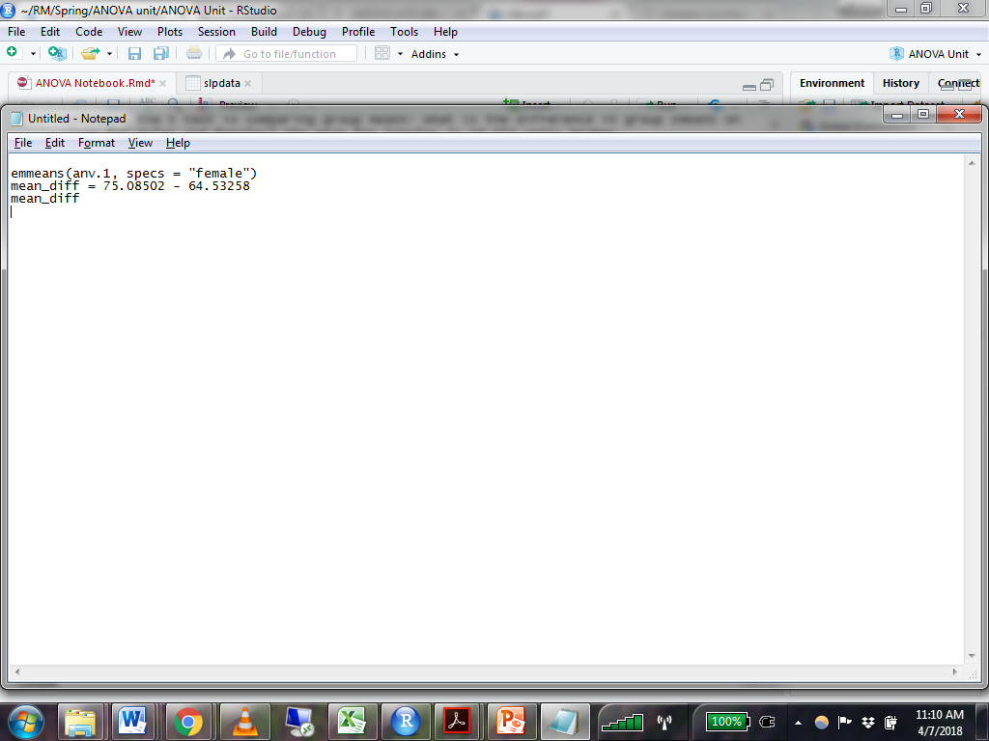

* 1. Results:

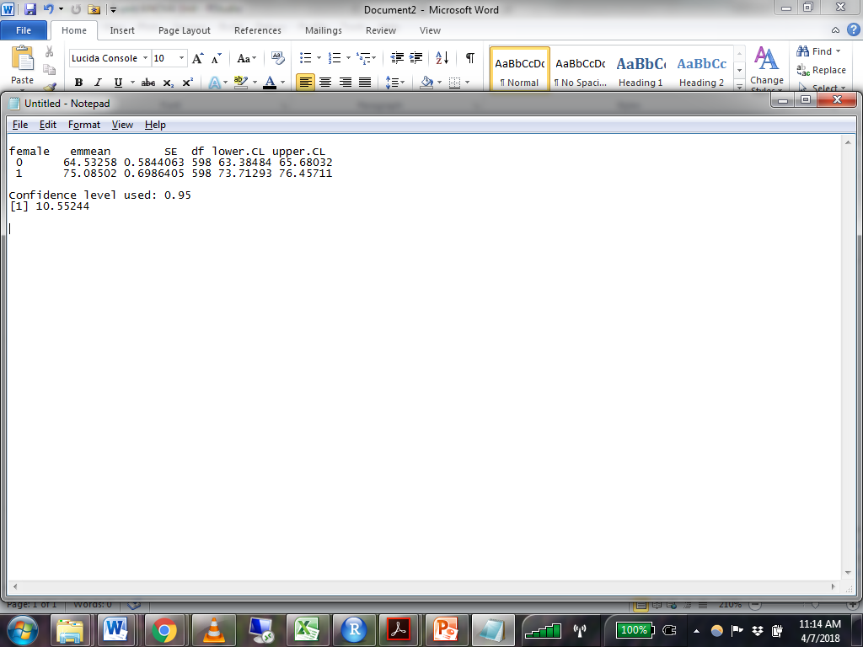

* 1. The emmeans column gives you the mean for each level of the predictor variable.
  2. The confidence intervals for these group means do not overlap. Therefore, the two groups differ significantly in their average level of sleep efficiency.
  3. Subtracting the two means gives a mean difference of 10.55. Because of the confidence intervals (and the F ratio above) we know that this is a significant difference. Females have a higher average score on sleep efficiency.

1. Conduct an SLR with sex as a categorical predictor of sleep efficiency. (Remember, this is equivalent to a t-test.) Be sure to dummy code your sex variable.

|  |  |
| --- | --- |
| Is there a significant difference between males and females on sleep efficiency? | There is a significant difference between male & female |
| *How do you know?* | The slope is 10.552, which is the predicted difference in sleep efficiency as female (the dummy coded variable) increases by 1 unit (moving from male to female). This slope is significant. |

1. Fill out the following table with appropriate values from each model

|  |  |  |
| --- | --- | --- |
|  | t-test | ANOVA |
| Mean Square Error (Residual) | 120.560 | 120.560 |
| F statistic, p value | 134.221, very small (<.001) | 134.221, very small (<.001) |
| Proportion of variance explained by sex | 0.183 | .18 |
| Difference in means between the two sexes | 10.55244 | 10.55244 |

Treatment Condition Predicting Sleep Efficiency: One-Way ANOVA vs. Regression (with categorical predictors)

1. Run this code to get the sleep efficiency means by treatment condition.
   1. We want to determine which, if any, of these are significantly different.



1. Run this code to conduct an ANOVA



* 1. Results:

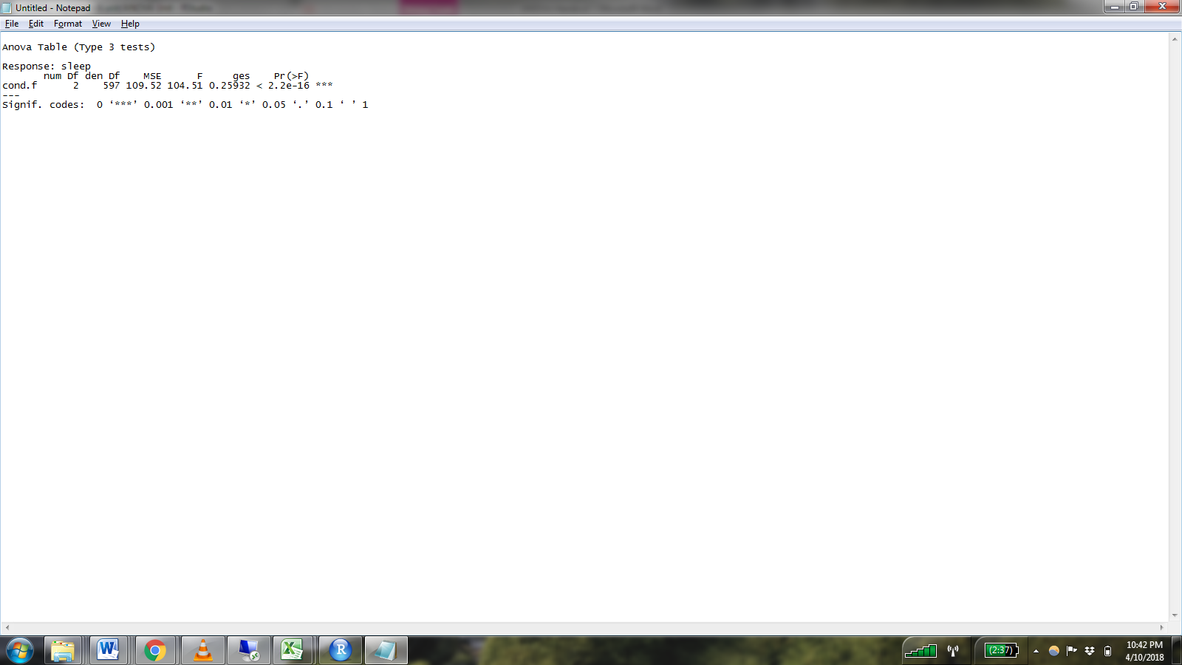

* 1. The F test is significant, telling us that our predictor is explaining a meaningful amount of variance. (i.e. Some of the group means are significantly different from one each other.) BUT, this time we have three levels of the predictor variable. There could be a difference between any two levels, or all three. Further analysis is required to identify the difference
  2. ges = proportion of variance explained by the predictor

1. Run this code to obtain estimated marginal means and confidence intervals



* 1. Results:

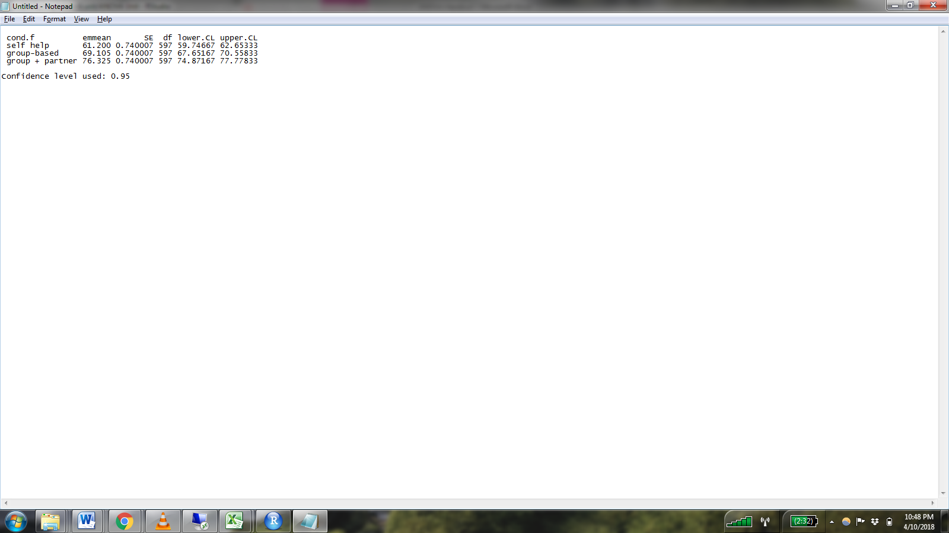

1. This time we’ll test some contrasts to evaluate the magnitude and significance of differences between treatment conditions



* 1. “***cond2_1***” is comparing condition 2 to condition 1. “***cond3_1***” is comparing condition 3 to condition 1.
     1. See Discovering Statistics Using R, chapter 10 for an explanation of contrasts.
  2. Results



* 1. The first contrast tells us that the difference in average sleep efficiency between treatment condition 2 and condition 1 is 7.905 and is statistically significant
  2. The second contrast tells us that the difference in average sleep efficiency between treatment condition 3 and condition 1 is 15.125 and is statistically significant

1. Estimate a regression model with treatment condition predicting sleep efficiency

|  |  |
| --- | --- |
| Is there a significant difference between treatment conditions on sleep efficiency? | There are significant differences among treatment conditions (when we compare cond2 & cond3 against cond1) |
| Which conditions are significantly different? | Condition 2 is significantly different from condition 1  Condition 3 is significantly different from condition 1 |
| *How do you know?* | The slopes for cond2 and cond3 are significant, indicating that there are significant increases when we move from condition 1 to condition 2 or condition 3. |

1. Fill out the following table with appropriate values from each model

|  |  |  |
| --- | --- | --- |
|  | Regression | ANOVA |
| Mean Square Error (Residual) | 109.522 | 109.52 |
| F statistic, p value | 104.51, very small (<.001) | 104.51, very small (<.001) |
| Proportion of variance explained by treatment condition | 0.259 | 0.25932 |
| meancond2 – meancond1 | 7.905 | 7.905 |
| meancond3 – meancond1 | 15.125 | 15.125 |

Sex AND Treatment Condition Predicting Sleep Efficiency: Factorial ANOVA vs. Multiple Regression

1. In the previous step, we were only interested in the effect of one predictor, while controlling for others. If we are interested in the effect of more than one categorical predictor, we consider a factorial ANOVA which looks at the dependent variable at all combinations of predictor levels.
2. Run this code to estimate an ANOVA with treatment condition and sex predicting sleep efficiency

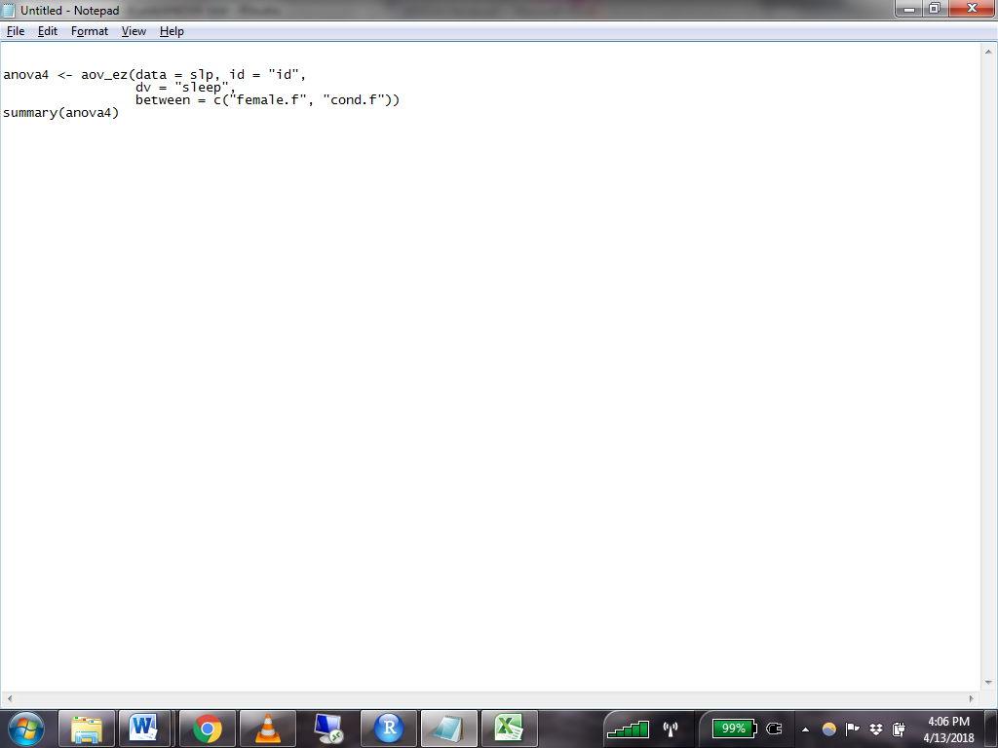

* 1. Results:

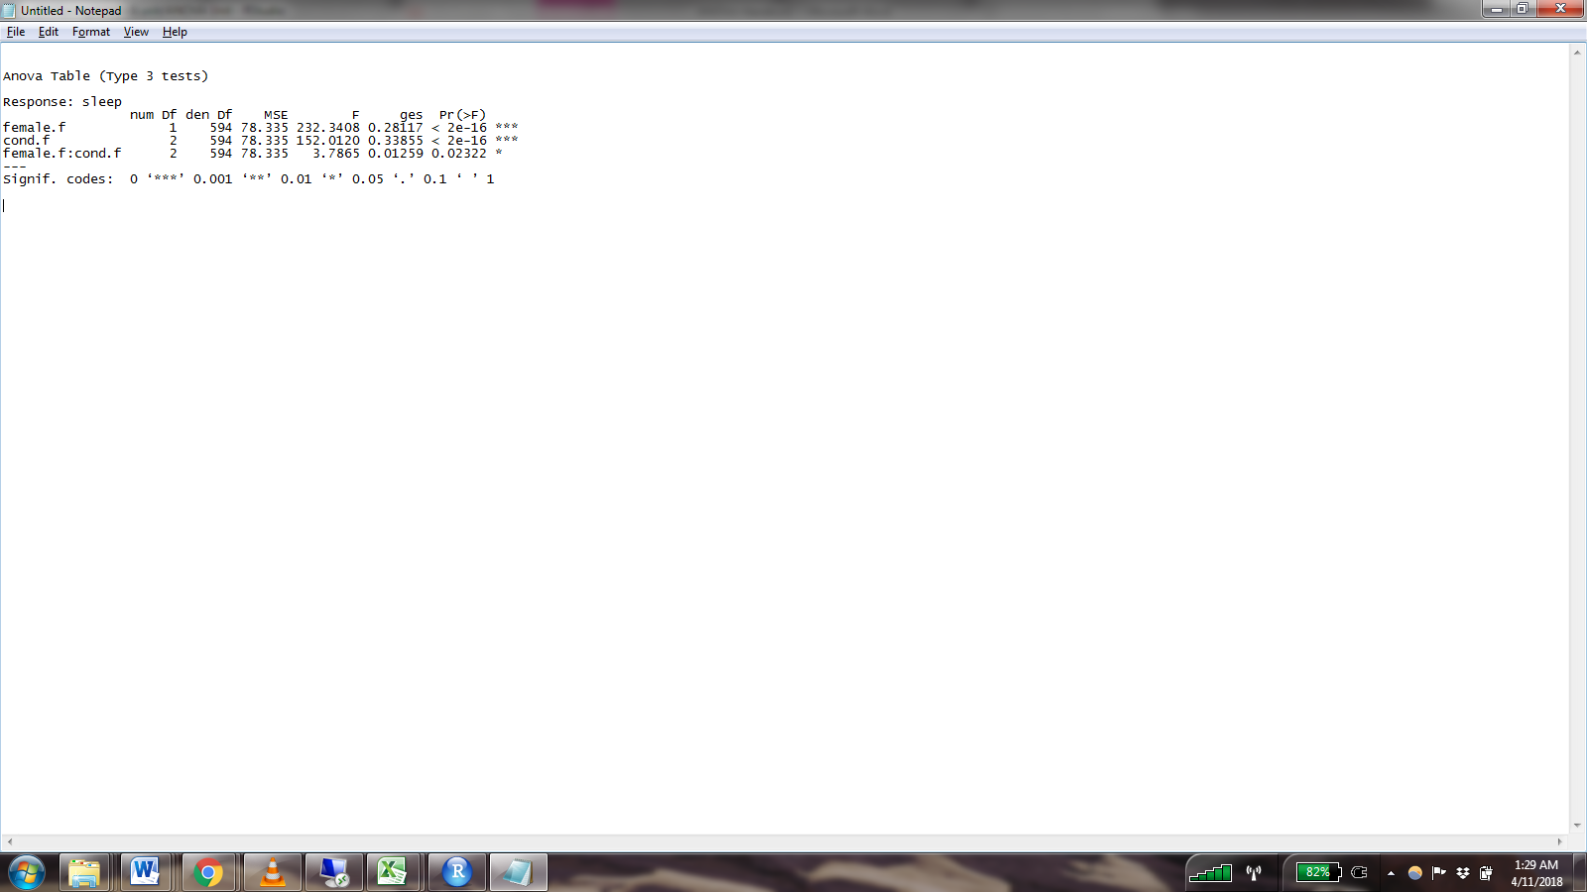

* 1. There appears to be a significant interaction between treatment condition and sex. So, let’s look at the estimated means.

1. Run this code to get the estimated marginal means:



* 1. Results:

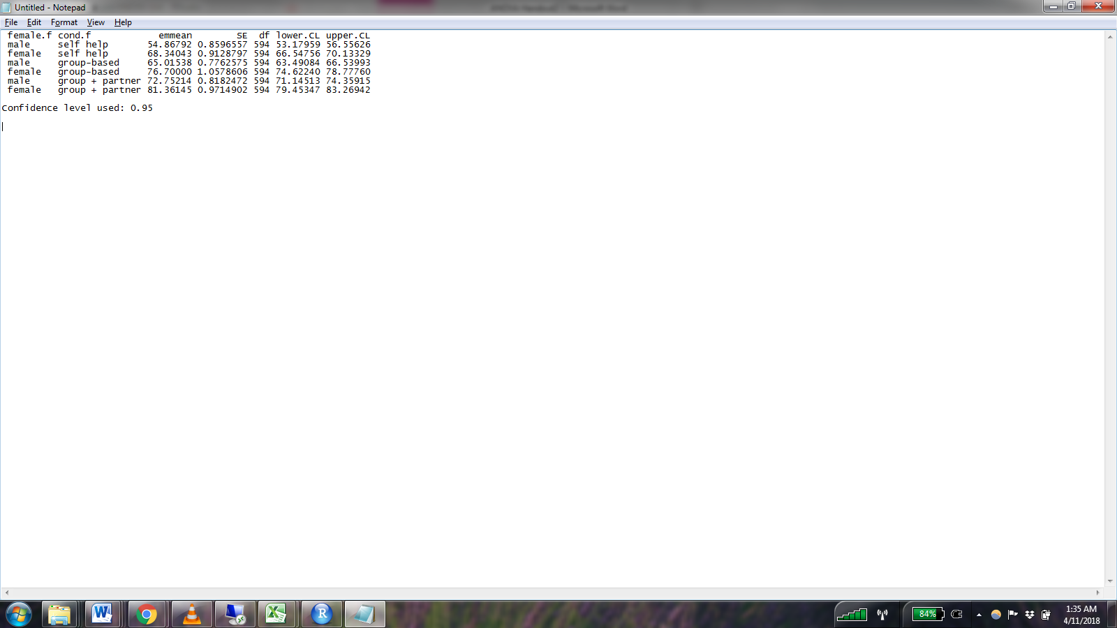

1. Now we have the estimated mean for each combination of sex and treatment condition, along with confidence intervals. To test the differences between the means, run this code some contrasts.



* 1. The contrast codes (e.g. -1, 1, 0, 0, 0, 0) contain six columns. These columns correspond to the unique combination of predictor levels (e.g. male:self-help). The order of the columns corresponds to the order in which the combinations appear in the output from emmeans() above. The first column represents males in the self-help condition. The second column represents females in the self-help condition, and so on.
  2. sex_diff_cond1 compares females to males in treatment condition 1
  3. sex_diff_cond2 compares females to males in treatment condition 2
  4. sex_diff_cond3 compares females to males in treatment condition 3
  5. Results:



1. Estimate a regression model to test the interaction between sex and treatment condition predicting sleep efficiency.
   1. Fill out the following table with appropriate values from each model

|  |  |  |  |  |  |  |
| --- | --- | --- | --- | --- | --- | --- |
|  | ANOVA | | | MLR | | |
|  | Treatment Condition | | | Treatment Condition | | |
|  | 1 | 2 | 3 | 1 | 2 | 3 |
| Meanfemale – meanmale | 13.472501 | 11.684615 | 8.609309 | 13.473 | 11.685 | 8.61 |
| Is the difference significant? | yes | yes | yes | yes | Can’t answer | Can’t answer |

Treatment Condition Predicting Sleep Efficiency (controlling for anxiety): ANCOVA vs. MLR (with categorical and continuous predictors)

1. Run this code to estimate an ANCOVA (analysis of covariance) model.
   1. ANCOVA allows you to control for continuous variables

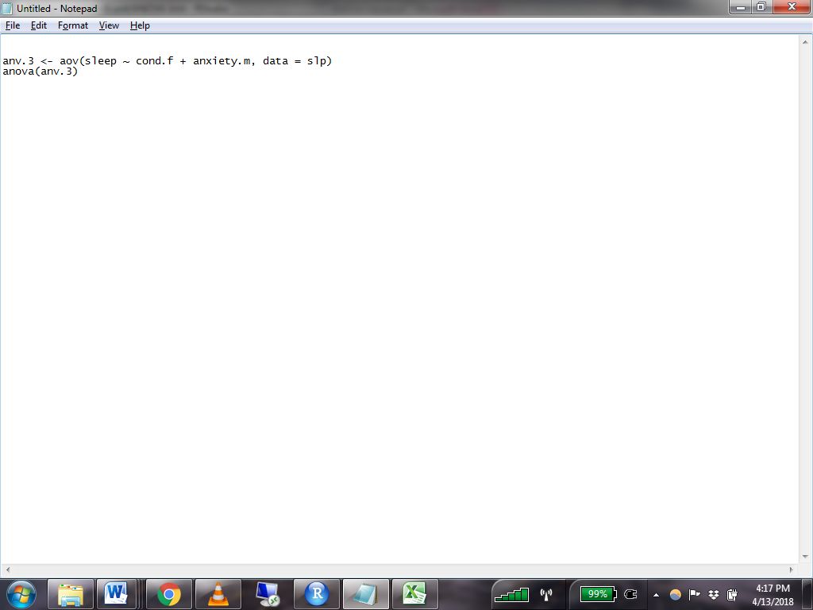

* 1. To run an ANCOVA, we need to use the function aov(). Instead of listing the variables as we have been, include a formula like you would for an lm() model. [1]
  2. Results:

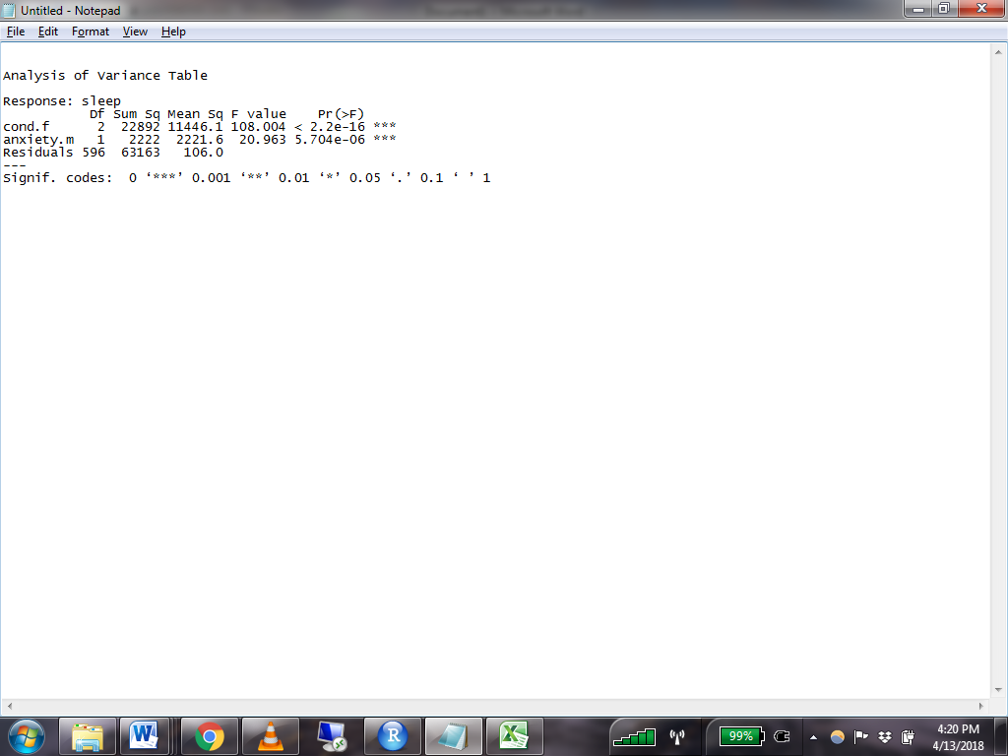

* 1. The effect of treatment condition is significant after controlling for anxiety. But we don’t know which conditions are different from one another yet.

1. Run this code to get the estimated marginal means.

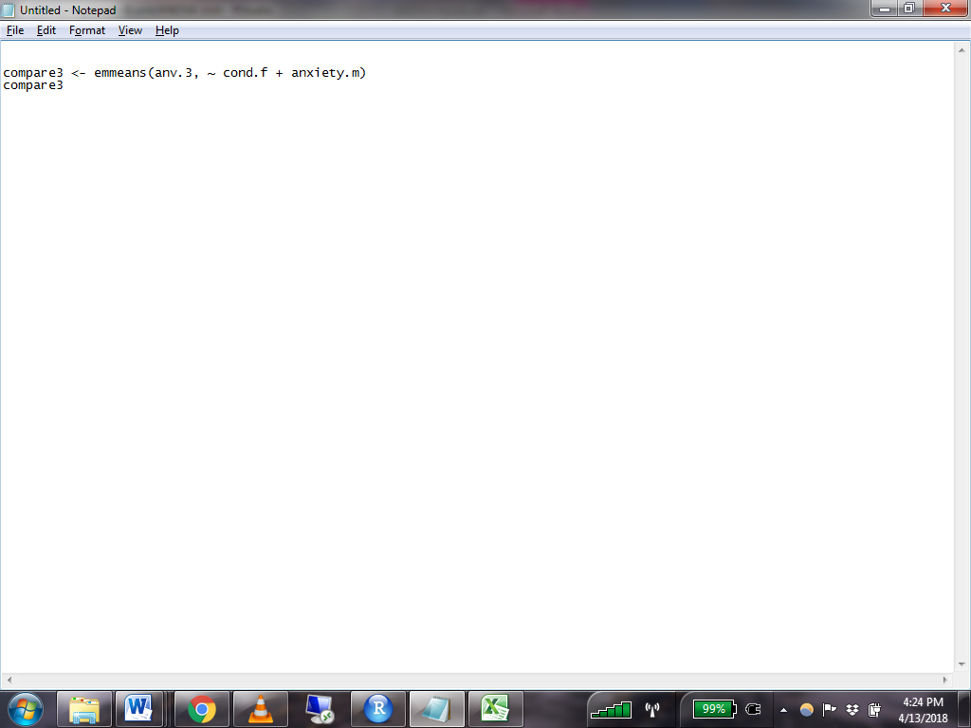

* 1. Results:

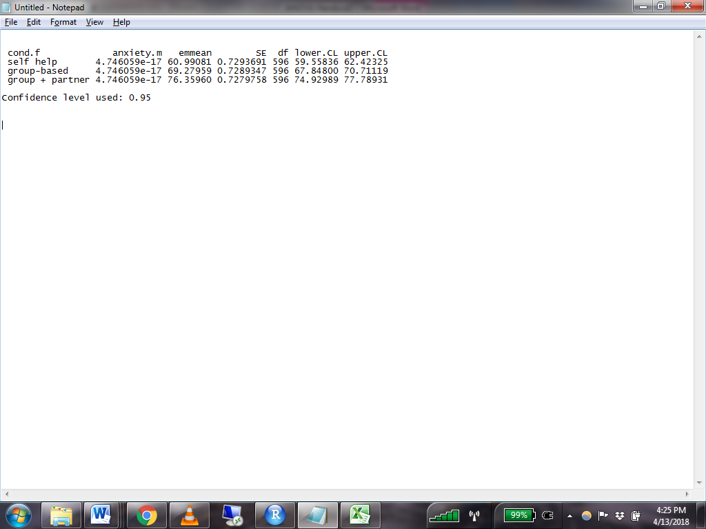

* 1. Anxiety is held constant at its mean (this value is essentially equal to zero).

1. Run this code to execute contrasts that compare the various levels of treatment condition.

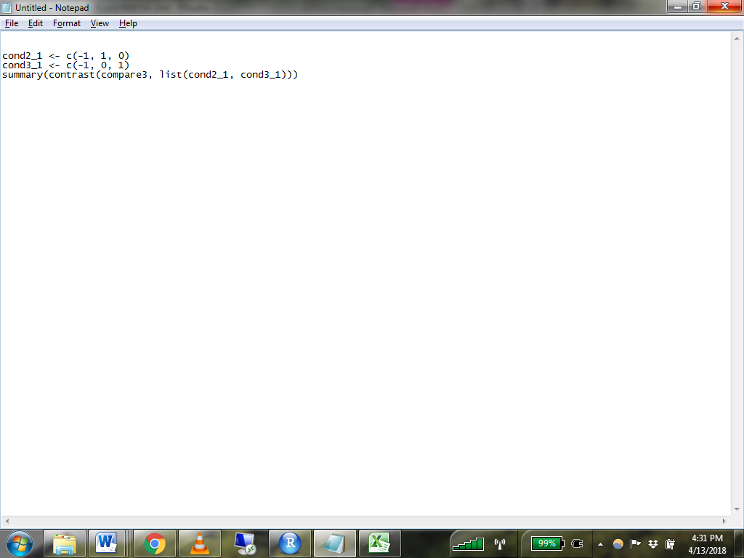

* 1. Results:

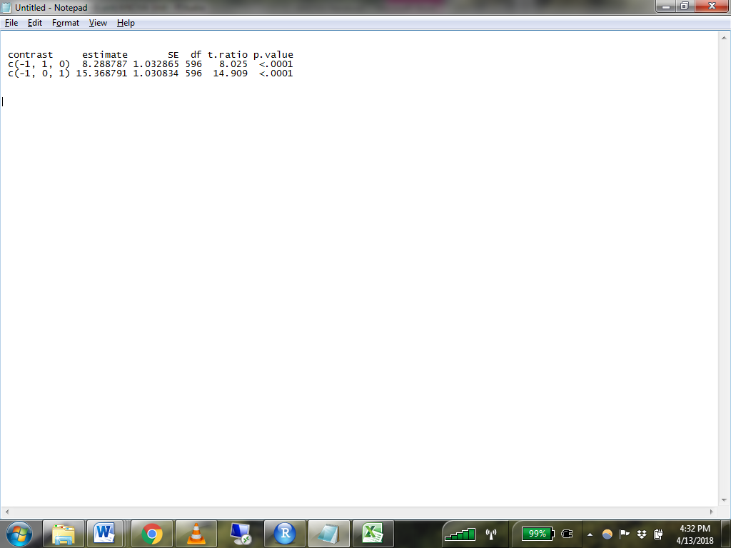

1. Execute a MLR model that predicts sleep from treatment condition and anxiety.
   1. Fill out the following table with information from both models

|  |  |  |
| --- | --- | --- |
|  | Regression | ANOVA |
| Which conditions are significantly different from each other? | Cond 2 & cond 1  Cond 3 & cond 1 | Cond 1 & cond 2  Cond 1 & cond 3  Cond 2 & cond 3 |
| *How do you know?* | There are different significances between cond2 compared to cond1, and cond3 compared to cond1, controlling for anxiety. | There are no overlaps in the Cis, after controlling for anxiety, the effects on sleep efficiency are different among all conditions. |
| Mean Square Error (Residual) | 105.978 | 106.0 |
| meancond2 – meancond1 | 8.289 | 8.288787 |
| meancond3 – meancond1 | 15.369 | 15.368791 |

Asbestos Exposure Predicting Lung Cancer: Chi-squared vs. Logistic Regression

1. Read in the data “asbestos.csv”
2. Run this code to format the data

asbestos <- mutate(asbestos,

asb_exp.f = factor(asbestos, levels = c(0,1), labels = c("no", "yes")),

cancer.f = factor(lung_cancer, levels = c(0,1), labels = c("no", "yes")))

1. Run this code to get a cross table of values for each combination of variables

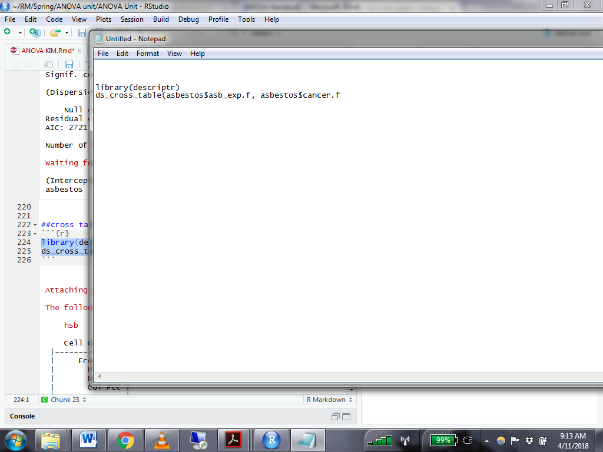

* 1. Results:

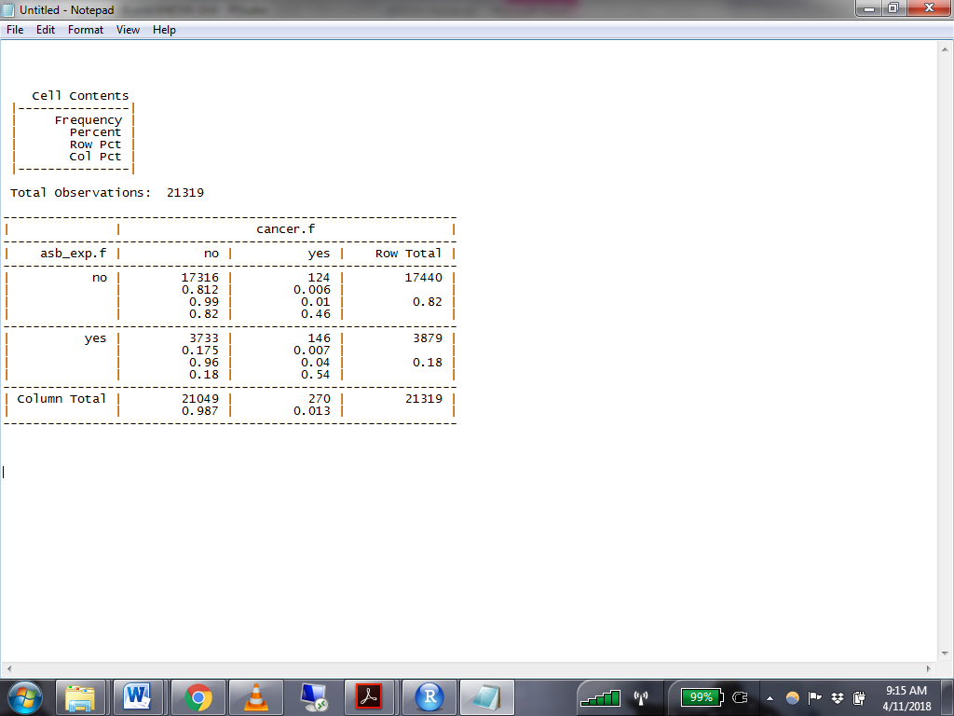

1. Chi-squared compares tables of categorical data. We want to determine if the distribution of people with cancer/no cancer is different for those who have been exposed to asbestos compared to those who have not.
   1. Run this code to conduct a chi-squared test.

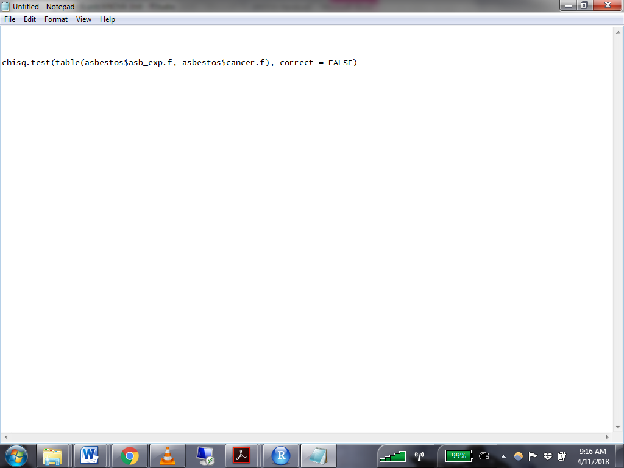

* 1. Results:

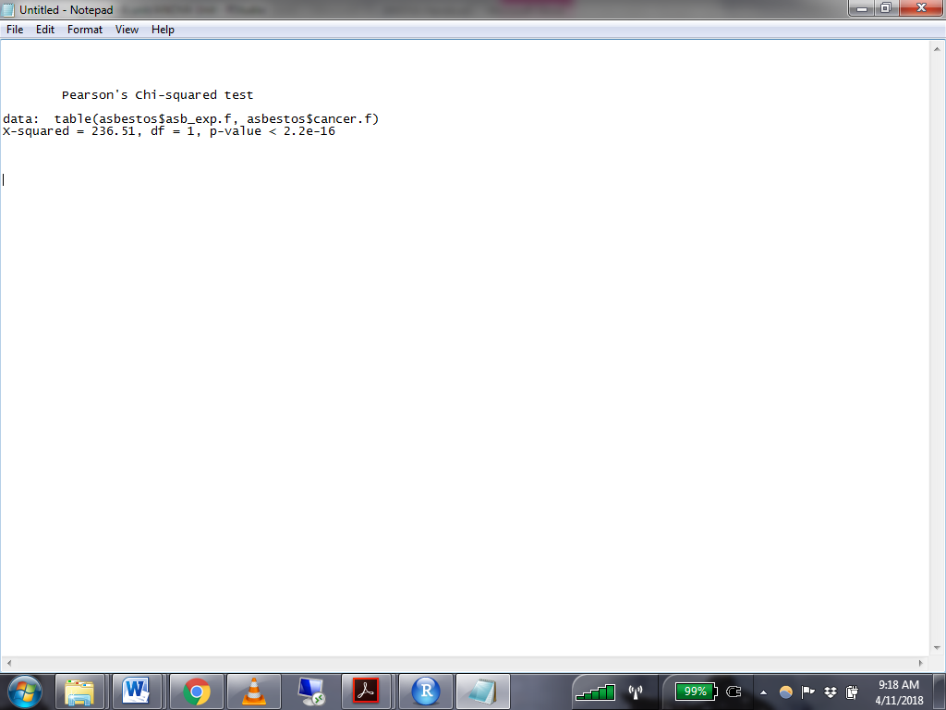

* 1. The significant Chi-squared test tells us that the presence of lung cancer is distributed differently amongst participants who have been exposed to asbestos compared to those who have not.

1. Conduct a logistic regression to determine the effect of asbestos exposure on lung cancer presence.

|  |  |
| --- | --- |
|  |  |
| Does exposure to asbestos significantly predict lung cancer presence? | Yes |
| Report the odds ratio (and confidence interval) for asbestos | OR = 5.461610801  CI (4.289961132, 6.963924435) |
| What are the advantages of using logistic regression over chi-squared? | We can tell where the differences are. The logistic regression not only tells us that there is a significant difference in the risk of lung cancer for people who are exposed to asbestos compared to those who are not exposed to asbestos, it also tells us the direction and magnitude of the difference. |

Gender and Attractiveness Predicting Speed Date Ratings: Mixed ANOVA vs. Multilevel Modelling

**Scenario**:

These fictional data are from the example in Discovering Statistics Using R, Chapter 14. Twenty participants (10 males/10 females) interact with confederates in a “speed dating” simulation. Confederates were selected to represent three levels of attractiveness: attractive, average, and ugly. Participants completed 9 speed dates (with 3 confederates from each level of attractiveness) and rated their desire to date the confederates on a scale from 0 – 100. We are interested in the interaction between gender and attractiveness. Do males and females rate confederates differently at each level of attractiveness?

Because each participant provided multiple observations, this experiment contains within-subjects elements. We must account for the nesting of observations within participants. However, the gender of the participants only varies between subjects. Because the design contains both within-subjects and between-subjects variables, it is called “mixed”.

**Variables of interest**:

participant- participant ID

gender- represents the gender of the participant (not the gender of the confederates). Gender does not vary within subjects, only between subjects.

looks- Attractiveness of the confederate. Dummy coded predictors have been created for you.

dateRating- participants’ rating of the date.

1. Read in the data “speedData.csv”
2. Run this code to execute a mixed ANOVA

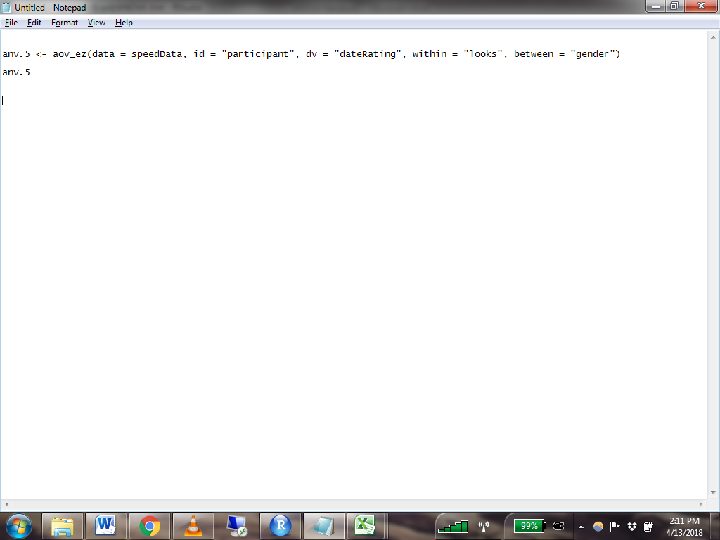

* 1. Looks is a repeated measure (each participant rated multiple confederates at the same level of looks), so we specify it as a within-subjects variable.
  2. Gender is constant within each subject. It only varies between subjects.
  3. Results:

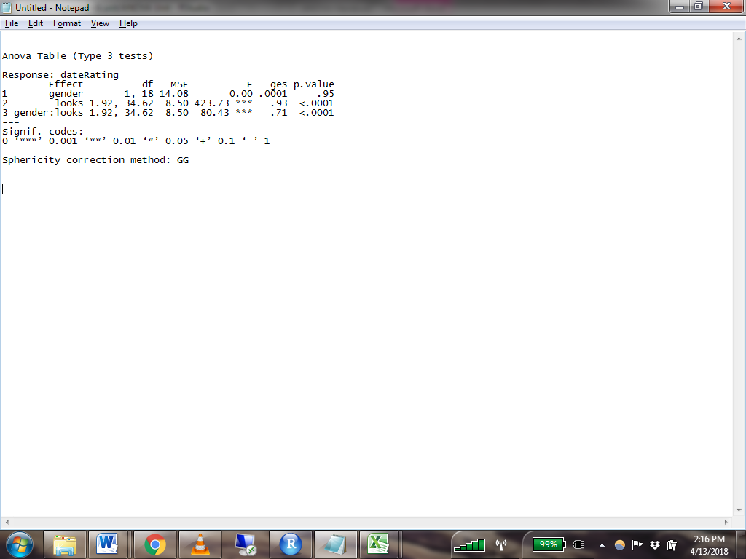

* 1. The main effect for gender is not significant. On average, males and females did not rate dates differently
  2. The main effect for looks is significant. On average, more attractive dates received higher ratings.
  3. The interaction between gender and looks is significant. Males and females rated dates differently at some levels of attractiveness, but we don’t know where the differences lie.

1. Run this code to get the estimated marginal means for each combination of looks and gender

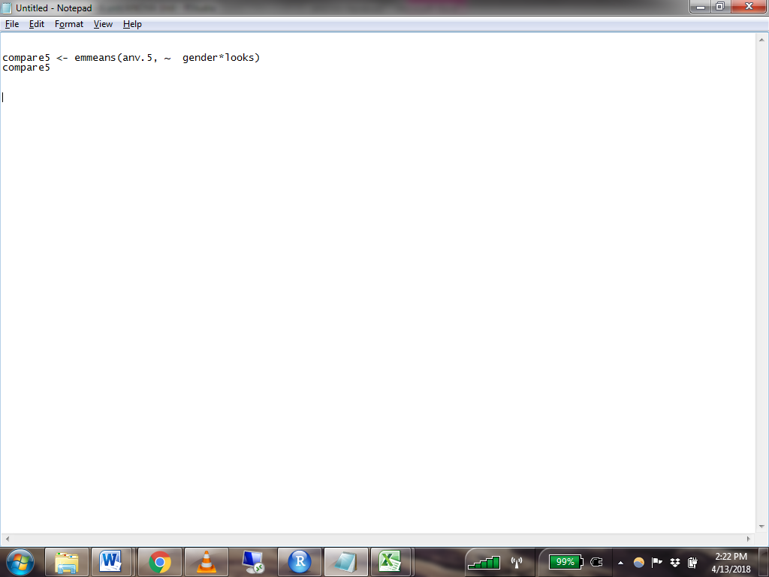

* 1. Results:

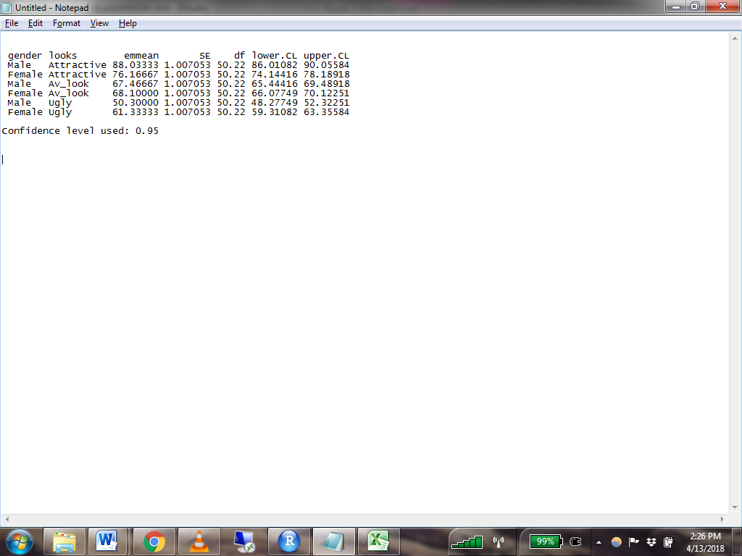

1. Run this code to set contrasts that compare males vs females for each level of attractiveness. The columns of the contrast code correspond to the order in which the combinations of variables appear in the emmeans() output above. The first column corresponds to male participants’ ratings of attractive confederates, the second to female participants’ ratings of attractive confederates, etc.

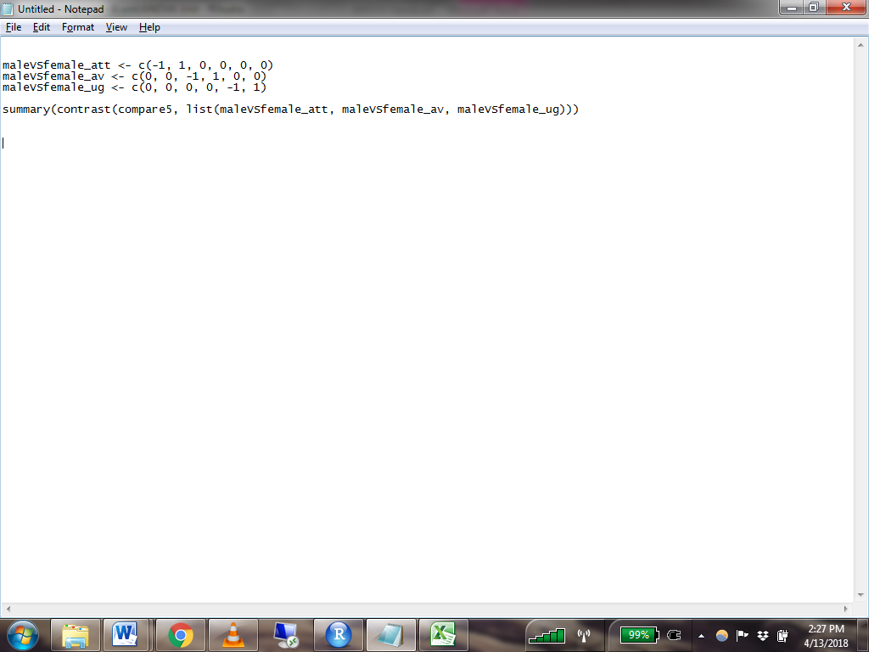

* 1. Results:

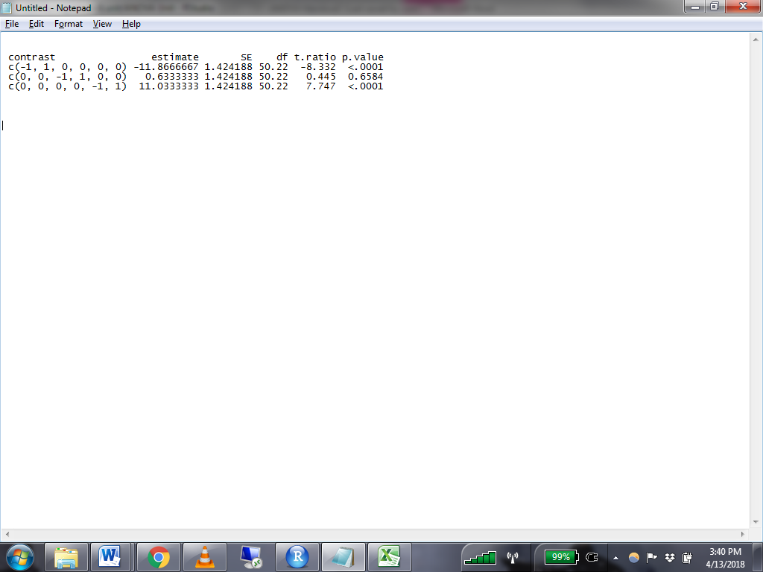

* 1. The contrast comparing females’ to males’ ratings of attractive confederates is significant.
  2. The contrast comparing females’ to males’ ratings of average confederates is not significant.
  3. The contrast comparing females’ to males’ ratings of ugly confederates is significant.

1. Conduct a multilevel regression model to test the effect of the interaction between gender and looks on date ratings. Include a random intercept and random effects for attractiveness of the confederate.
   1. Fill out the table using information from each model

|  |  |  |
| --- | --- | --- |
|  | ANOVA | MLM |
| Is the interaction significant? | The interaction between gender and looks is significant. Male and female rate differently at different levels of attractiveness. | There’s no significant interaction between gender and look at the average level of look  There’s significant interaction between gender and look at the attractive level of look |
| How do you know? | p-value for the interaction term between look and gender is small and significant (<.001) | p-value for the interaction between av_look & female is not significant  p-value for the interaction between attractive & female is small and significant |
| How do males and females differ in their ratings of attractive dates? | When the confederate is rated as attractive, on average, males rate the date 11.8666667 pt higher than females  When the confederat is rated as average looking, on average, males tend to rate the date 0.6333333 pt lower than females (but this value is not significant)  When ther confederate is rated as ugly, on average, males tend to rate the date 11.0333333 lower than females | When the confederate is rated as attractive, on average, males rate the date 11.867 (=11.033- 22.900) pt higher than females  When the confederat is rated as average looking, on average, males tend to rate the date 0.633 (=11.033- 10.400)pt lower than females (but this value is not significant)  When ther confederate is rated as ugly, on average, males tend to rate the date 11.033 lower than females |
| *Explain where your answer came from or show your work* | The number is from the contrast table | Calculated using the simple slope for female and the interaction between fml:attractive & fml:av_look |
| How do males and females differ in their ratings of average dates? | There’s not significant difference between male & female when it comes to rating average dates | There’s not difference between male & female here |
| *Explain where your answer came from or show your work* | The t-test for the contrast is not significant | The slope for the interaction fml:av_look is not significant |
| How do males and females differ in their ratings of ugly dates? | When ther confederate is rated as ugly, on average, males tend to rate the date 11.0333333 lower than females | When ther confederate is rated as ugly, on average, males tend to rate the date 11.033 lower than females |
| *Explain where your answer came from or show your work* | Contrast | Simple slope in the MLM |
|  |  |  |

1. The afex package contained a bug that causes erroneous results for ANCOVA models. The bug has been fixed, but for now you must download the developer’s version of the package from github in order to run an ANCOVA using afex:

   *install_github(singmann/afex)*

   *anv.x <- aov_ez(id = "id", dv = "sleep", data = slp, between = c("cond.f"),*

   *covariate = c("anxiety.m"), factorize = FALSE)*

   *compare.x <- emmeans(anvmod, ~ cond.f + anxiety.*